ABSTRACT TITLE IN BOLD TIMES NEW ROMAN WITH CAPITALS, FILL TO THE LEFT MARGIN, 12PT, MAX. 255 CHARACTERS (INCL. SPACES)

A. Author¹, B. Author^{2*} and C.D. Author²

¹Institution 1, Street, Postcode, City, Country
²Institution 1, Street, Postcode, City, Country
*e-mail: B.Author@abc.abc
All manuscripts must be written in English. Only Word (*.doc) files are accepted. Text: 12 pts Times New Roman, spacing 15 pts, margins 2.5 cm from all sides, references numbered as [1], [2] and listed at the end, half-tone photographs are accepted, coloured pictures are not allowed.
Manuscripts of the presented talks should be prepared on two or four A4 pages. Extended abstracts of the poster/oral contributions should be two A4 pages long. The authors are requested to submit one camera-ready copy according to the following guidelines and to send the abstract as a "*.doc" and "*.pdf" file to: fumici@isibrno.cz by April 23, 2012. Include the fonts you have used to the "*.pdf" file, please.
Seminar in 2012 is the thirteenth in the series of meetings. The first meeting was held in 1989 in Brno, as well as the second one in 1990. The following seminars were organized biannually in Skalský dvůr near Brno.
The Seminar is intended for discussions of questions regarding the instrumentation and methodology in charged particle optics and surface physics. Selected topics will be introduced by top specialists with emphasis on questions already recognized but not fully answered yet. Presenters are expected to present introductory talks of the length of about 20 min. and the style according to their own judgement, presenting facts and still open problems relevant to the topic, and they are supposed to present the subsequent discussions within the full audience. Several shorter oral presentations can be added to each topic. The number of participants is limited to 50.
Presentation of posters is highly recommended. Seminar Proceedings will be published.
The seminar takes place in pleasant surroundings of the Bohemian-Moravian Highland, roughly 50 km northwest from Brno. The seminar is organized as a closed meeting in a fully equipped conference centre that is localized outside human settlements, in the seclusion at the edge of a small lake, enclosed with a forest and fields.
The hotel offers accommodation in double bed ensuite rooms. Many services are available, such as photocopy and fax machines, Wi-Fi Internet access, tennis, table tennis, volleyball, swimming pool and sauna, bicycles, etc. The lake is suitable for swimming, fishing and rowing - fishing tackles, permits and boats are available.

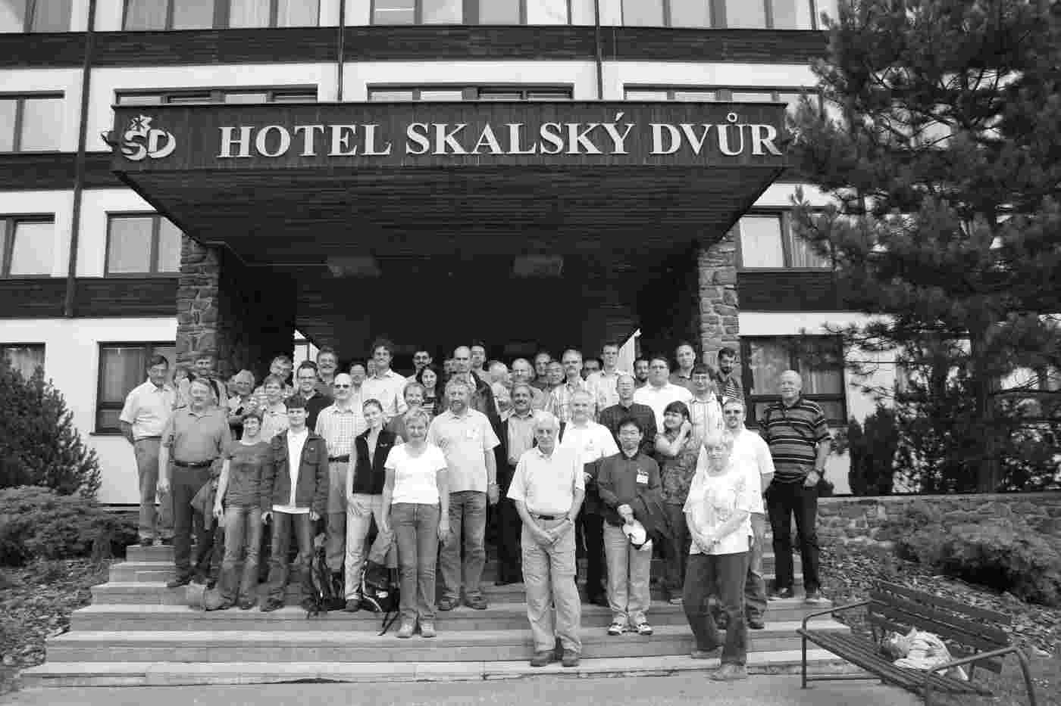
Figure 1 Photo of participants of 11th International Seminar on Recent Trends in Charged Particle Optics and Surface Physics Instrumentation.

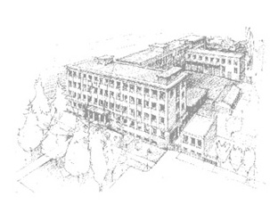
Figure 2 Institute of Scientific Instruments of the ASCR, v.v.i., Brno, Czech Republic.

References:
[1] Author A., Author B. and Author C.D., Journal volume (year), p. x-y.

